Q)Draw your Home Network Topology and explain how you are accessing the RPS Lab environment:-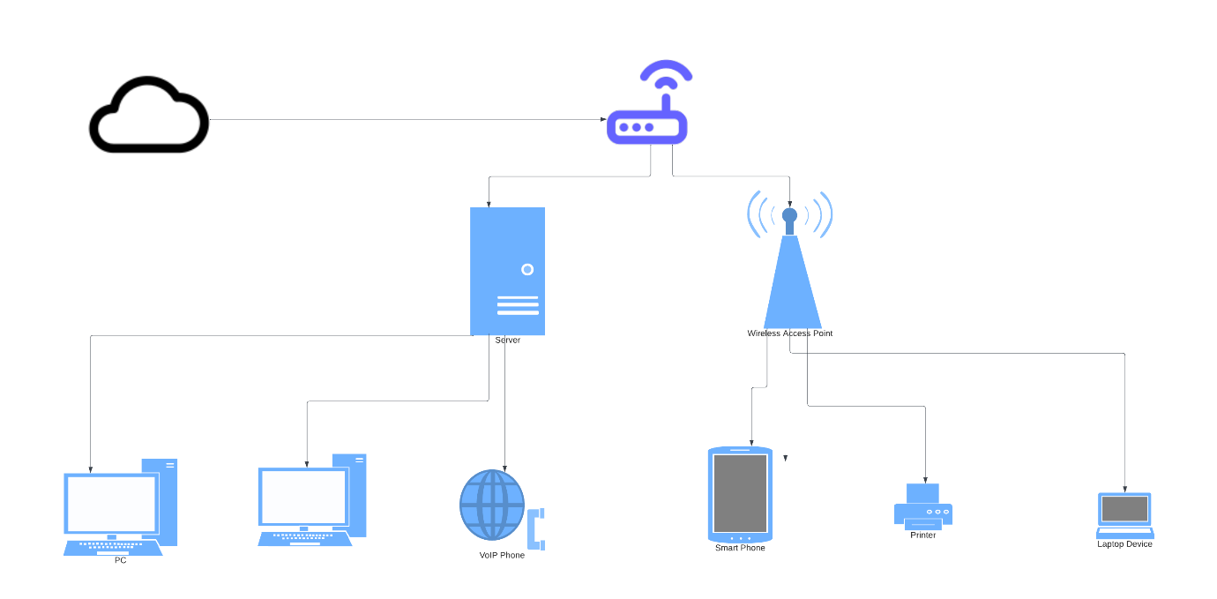

Home Network Topology

--------------------------------------------------------------------------------------------------------------------------------------

Accessing the RPS Lab environment:- 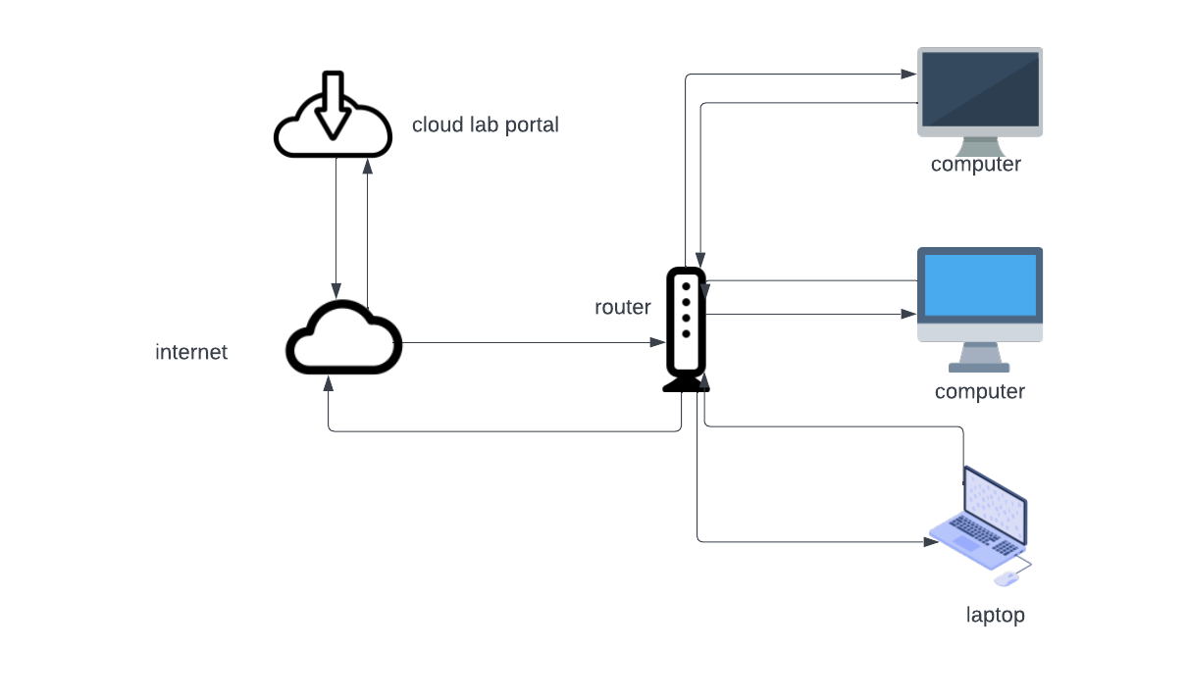Components:-

1) Computers/laptop

2) Router

3) Internet

4) Data fetched/cloud lab

Procedure:-

At first the computer/laptop are connected to the internet by connecting to the router. Where the router id connected to the internet via cloud.

In the second stage we browse internet and search the link are the source which is what we are required. I.e. the RPS cloud lab.

The internet fetch for the query and display the required or the related solution.

By clicking the suitable link we can see the required destination.

All the above process are two way directional.

Q) Identify a real-world application for both parallel computing and networked systems. Explain how these technologies are used and why they are important in that context?

Sol) parallel computing:-

Parallel programming is a programming model that allows a computer to use multiple resources simultaneously to solve computational problems. It allows computers to process several problems at the same time. Large problems can often be divided into smaller ones, which can then be solved at the same time.

Benefits parallel programming:-

Benefit of parallel computing is its ability to solve complex problems. Parallel programs can divide complex problems down into smaller tasks and process these individual tasks simultaneously. By separating larger computational problems into smaller tasks and processing them at the same time, parallel processing allows computers to run faster.

Parallel programming hardware system may require more parts than a serial processing system, they are more efficient at performing tasks. And they produce more results in less time than serial programs and hold more financial value over time.

A computer that uses parallel programming can make better use of its resources to process and solve problems.

Limitations parallel programming:-

It addresses Parallel architecture that can be difficult to achieve. In the case of clusters, better cooling technologies are needed in parallel computing.

It requires the managed algorithms, which could be handled in the parallel mechanism. The multi-core architectures consume high power consumption.

The parallel computing system needs low coupling and high cohesion, which is difficult to create.

The code for a parallelism-based program can be done by the most technically skilled and expert programmers.

Real-world application:-

Multithreading is a parallel computing software method that works best in parallel computer systems.

Multiprocessing module simplifies parallel programming in the Python language.

Another example of parallel processing is Intel processors, which run most high-power modern computers.

Networked systems:-

A network system is a system attached to two or more communication links, wired or wireless.  The goal of such a network system is to deliver information from one communication link to another, a network system is a computational system that executes protocol stacks and switches data among the protocol stacks.

The networked system is a set of devices (often refer as nodes) connected by communication links.

Here node can be a computer, printer, etc. which are capable of sending and receiving the data generated by other nodes of network.

Benefits of networking system:-

File sharing - you can easily share data between different users, or access it remotely if you keep it on other connected devices.

Resource sharing - using network-connected peripheral devices like printers, scanners and copiers, or sharing software between multiple users, saves money.

Sharing a single internet connection - it is cost-efficient and can help protect your systems if you properly secure the network.

Increasing storage capacity - you can access files and multimedia, such as images and music, which you store remotely on other machines or network-attached storage devices.

## Limitations of networking system:-

When multiple devices are connected to a network, there is a greater potential for unauthorized access and data breaches. Hackers can exploit vulnerabilities in the network infrastructure or gain access to sensitive information through one compromised device.

Maintaining computer networks is a costly and time-consuming affair.

As computers in a network are interconnected, there is a high possibility that if one of the computers is affected by the virus, others too can get affected.

Real-world application:-

|  |  |
| --- | --- |
| E-commerce | Buying and selling items online |
| Communication | Video calls, e-mails and file transfers |
| Gaming | Quiz games |
| Education | Information on the  World Wide Web (www) helps students |